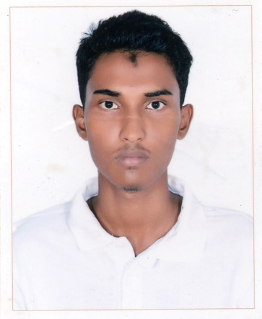

Curriculum Vitae

Of

**Mohammad Hasibul Hossain**

Permanent Address: - House-48/2, Baishtake, Mirpur 13, Dhaka-1216

**Mobile:** 01687268343

**Carrier Objective:** To work in the educational sector of 10MintueSchool, in its Education Section Department, and grow rapidly with increasing responsibilities.

**Educational Qualification:**

|  |  |  |  |  |
| --- | --- | --- | --- | --- |
| **Course** | **School, College and University** | **Board** | **Year of Passing** | **GPA & CGPA** |
| S.S.C. | Shaheed Police Smrity School and Collage, Mirpur 14. | Dhaka | 2012 | 4.94 |
| H.S.C. | Shaheed Police Smrity School and Collage, Mirpur 14. | Dhaka | 2014 | 5.00 |
| B.Sc. in CSE | Bangladesh University of Business and Technology, Rupnagar R/A, Dhaka. | Dhaka | 2019 | 3.58(running) |

**Personal Traits:**

* Fluent in Both Bengali and English language.
* Strong motivational and leadership ability.
* Good communication and organizing skill.
* Strong problem-solving and decision-making ability.
* Ability to work as individuals as well as group.

**Technical Skills:**

* Computer proficiency:
* MS Word, MS PowerPoint, MS Excel, MS Access, Adobe Photoshop, Internet Browsing,
* Programing and Software knowledge:
* C, C++, Java, Python, MATLAB, Java script, CSS, HTML, PHP, MySQL.

**Hobbies and Interest:**

Listening Music,

Watching Sci-fi movies,

Programming,

Travelling,

Working out.

**Personal Information**

Father Name: MD Monowar Hossain

Mother Name: Hasina Akhter

Date of Birth: 08th Febuary,1996

Permanent address: House-48/2, Baishtake, Mirpur 13, Dhaka-1216

Nationality: Bangladeshi

Blood Group: B+

Religious Status: Islam  
Nationality: Bangladesh

**Social Profiles ID:**

Facebook: <https://www.facebook.com/hasib.hosan>

LinkedIn: <https://www.linkedin.com/in/hasib-hosen-82319b135/>

GitHub: <https://github.com/Hasib192>

Urionlinejudge: <https://www.urionlinejudge.com.br/judge/en/profile/66619>

Gmail: [hasibhosen7612@gmail.com](mailto:hasibhosen7612@gmail.com)

**References:**

1. Dr. M. Ameer Ali

Professor and Chairman of CSE in BUBT.



Signature